* OVERVIEW : https://www.guru99.com/dimensional-model-data-warehouse.html#elements-of-dimensional-data-model
  1. Definiton : Dimesion modelling:
     + Data structure technique
     + Purpose : optimize the database for faster retrieval of data
     + Consists of facts and dimension tables
  2. Relational model vs dimensional model
     + Rm – optimized for addition updating deletion of data in real time ol transaction system – used in relational systems
     + Dm – designed to read summarize analyse numerical info -- used in dwh systems
  3. Elements of ddm(dimensional data model):

Considering an example of business process – Sales

* + 1. Fact: measurements / metrics from your business process. E.g Sales business process – measurement is quarterly sales number
    2. Dimension: window to view information in the facts - who what where of the fact i.e customer names(who), location (where), what (product name).
    3. Attribute: various characteristics of dimension in dimensional data – used to search filter or classify facts

e.g dimension – location then attributes are state, country, pincode etc

* + 1. Fact table : primary table in dm. Contains – facts(measurements), foreign key to dimension table.
    2. Dimension table : theses contain attributes
  1. Schema :
     + Star : It contains a fact table surrounded by dimension tables.
       - 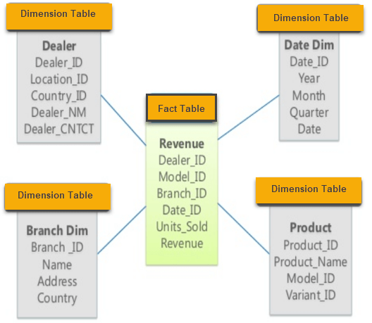
     + Snowflake : One fact table surrounded by dimension table which are in turn surrounded by dimension table
       - 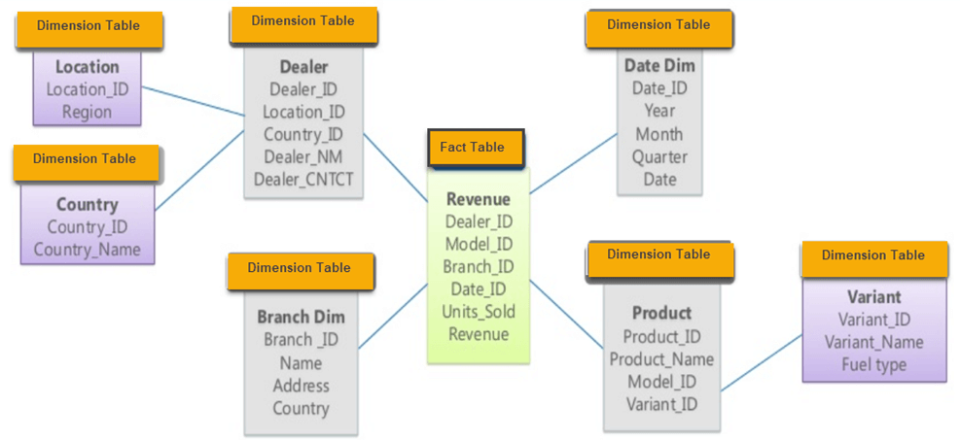

**What is denormalization and normalization?**

Denormalization and normalization are two opposite ways of organizing data in a relational database. Denormalization means combining data from multiple tables into one, reducing the number of joins and improving query performance. Normalization means splitting data into multiple tables, eliminating redundancy and ensuring data integrity. Both methods have advantages and disadvantages, depending on the context and the goals of the data warehouse.